TASK 12:
class Solution {
public boolean isPalindrome(ListNode head) {
ListNode slow = head, fast = head.next;
while (fast != null && fast.next != null) {
slow = slow.next;
fast = fast.next.next;
}
ListNode current = slow.next;
slow.next = null;
ListNode previous = null;
while (current != null) {
ListNode temp = current.next;
current.next = previous;
previous = current;
current = temp;
}
while (previous != null) {
if (previous.val != head.val) {
return false;
}
previous = previous.next;
head = head.next;
}
return true;
}
}

Case 1:
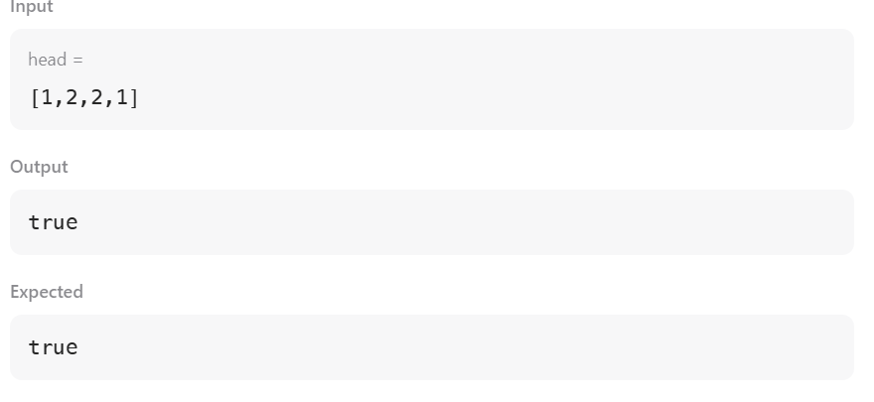
Case 2:
